Flagpole Photographers invites you to join our club!

Do you want to……

- Explore more about the Art of Photography?
- Meet like-minded people?
- Attend programs to learn new techniques?
- Take field trips to exciting local photo locations?
- Enter photo competitions?

Photographers of ALL levels and ages are
welcome to join!

Flagpole Photographers Camera Club
Newtown Senior Center
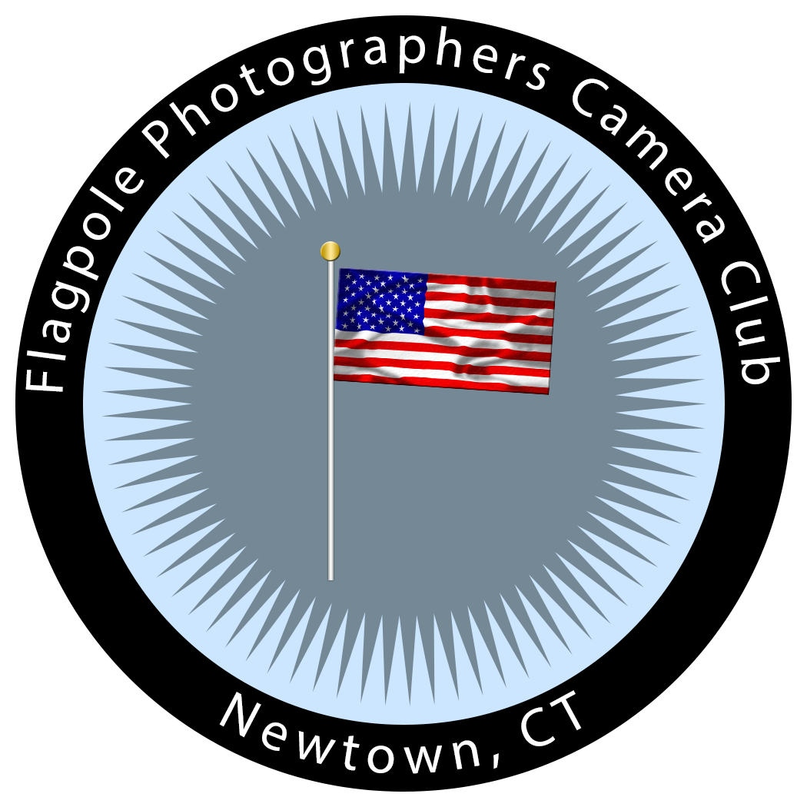
14 Riverside Road, Sandy Hook, Connecticut

Our complete calendar of events are listed on our web site
FlagpolePhotographers.com

Email us at info@flagpolephotographers.com

Or come to our next event and talk to our members!

